**Branch and PR Process:**

Please create a branch first.

<https://itsals.visualstudio.com/Crew/_git/TestAutomation/branches>

(You might not see the feature/ JCTE_Client as it’s deleted purposefully)

Click on New Branch Based on Develop - > feature/InSprint_PR/JCTE_Client

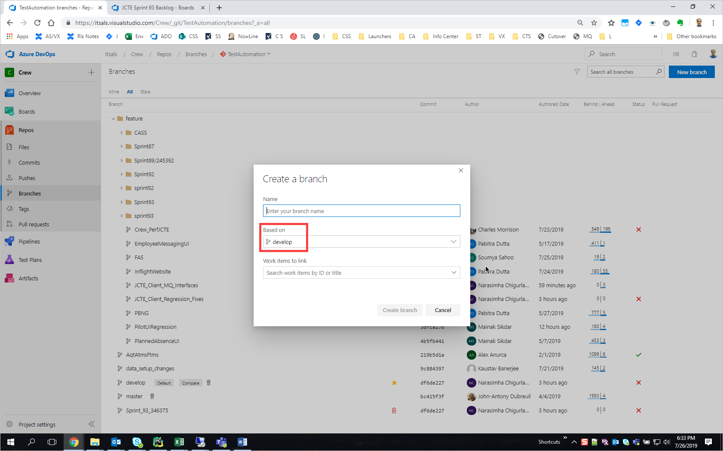

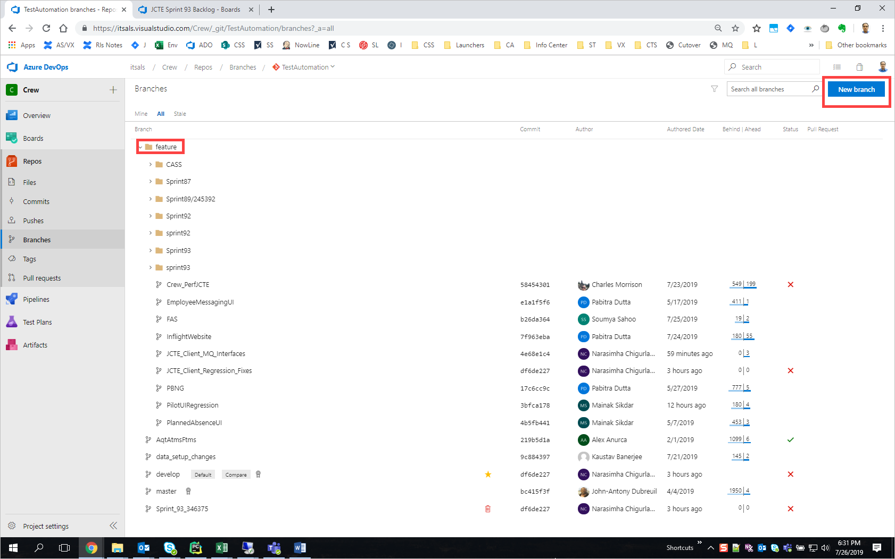

Get your changes done on that created Branch.

Run the tests by pointing the build pipeline to that branch. Have the successful results and then raise a PR on the newly created branch.

**To run the tests on the pipeline from the newly created branch, please refer to the below:**

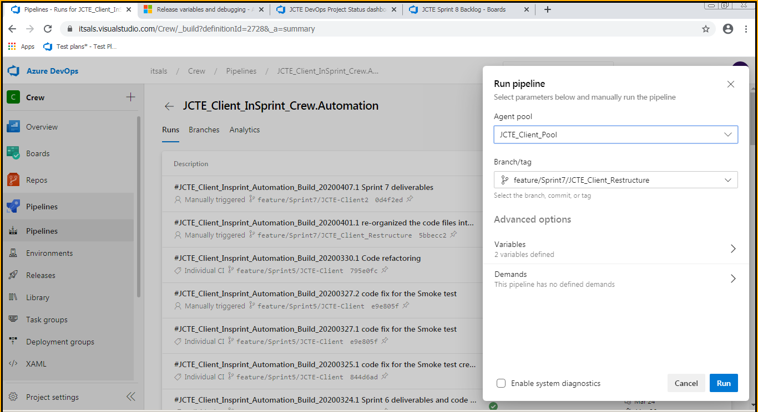

Once the PR approves and the code is in Develop branch, the newly created Branch will be deleted. This will continue.

# Steps to create a Pull Request:

Please note the below before raising a PR:

PR should be raised whenever a test case and or a functionality is done, tested, pulled the latest code and then pushing the updated code to repo and then PR should be raised. So it will be once in 2 days or 3 days…could be 3 PRs + in the sprint duration. Not raising a PR at the end of the sprint, so that code within the sprint is on the updated, not waiting till end of the sprint. This is applicable for new TC development and for maintenance as well. New test cases 2 or 3 developed and then raise a PR, maintenance one set of test cases fixed need to go for a PR. We need to get the user story created accordingly, like 2 or 3 test cases in one user story or similar functionalities.

We should not be waiting till end of sprint for a PR. Please let us know for additional info.

Navigate to:

<https://itsals.visualstudio.com/Crew/_git/TestAutomation/pullrequests?_a=mine>

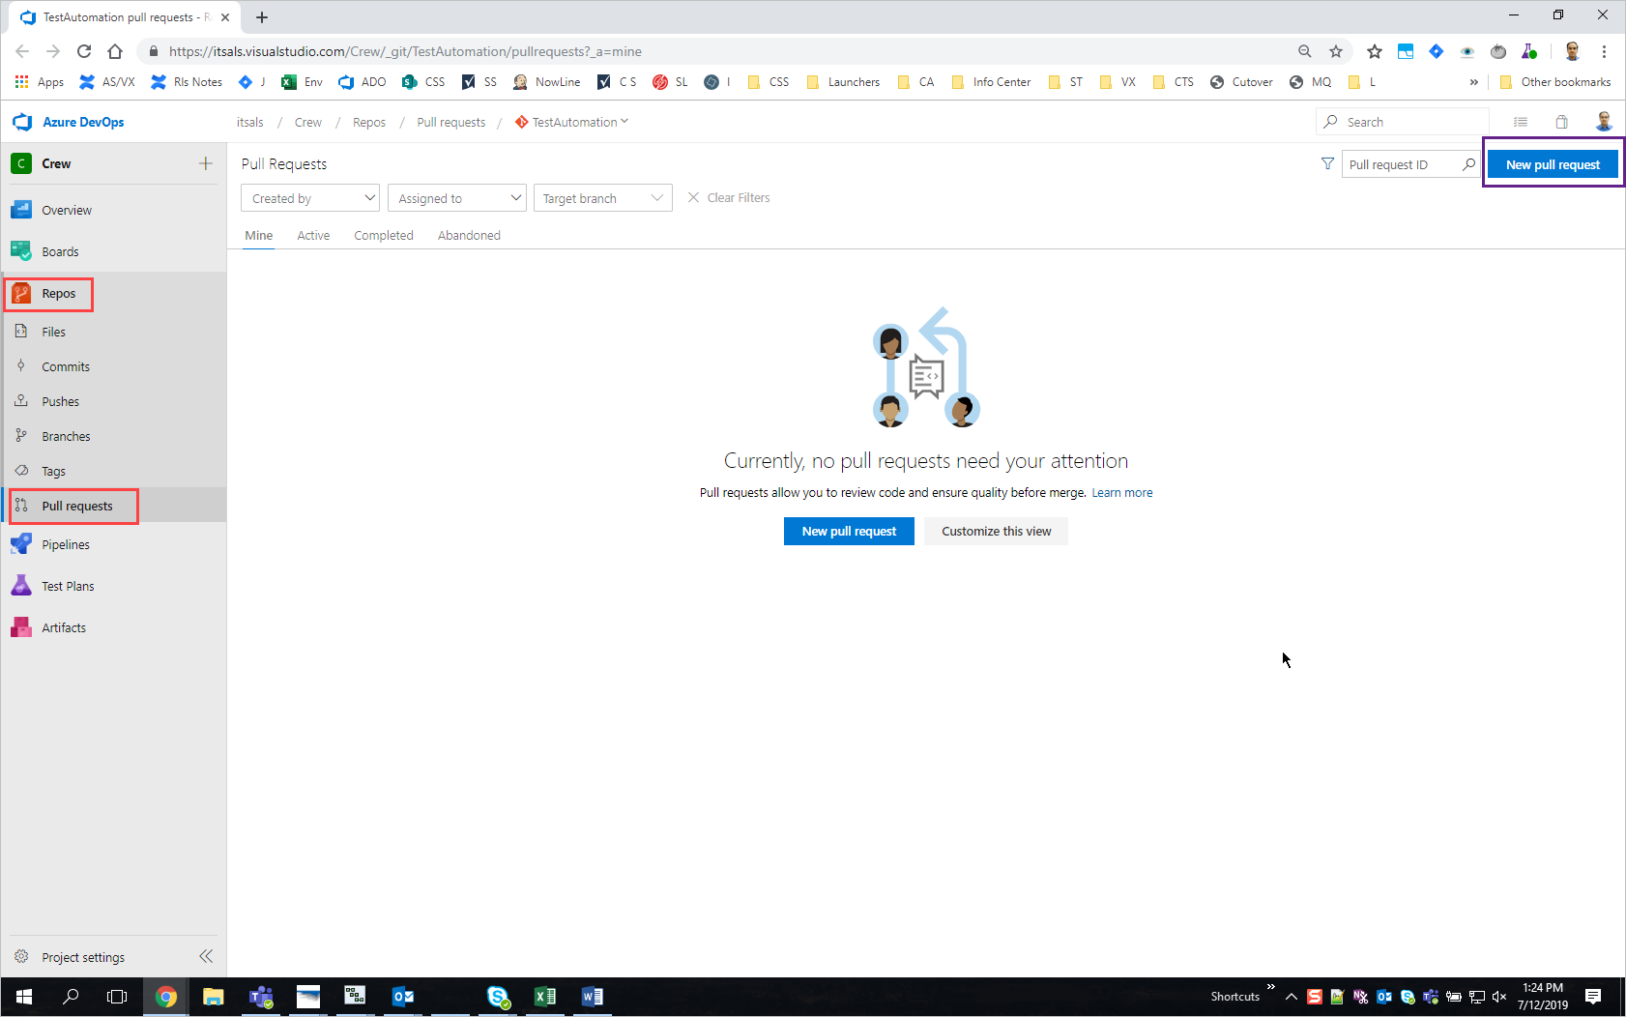

Click on New Pull request (blue button in the body of the page also works) then will see below.

Please see the highlighted in yellow for ex

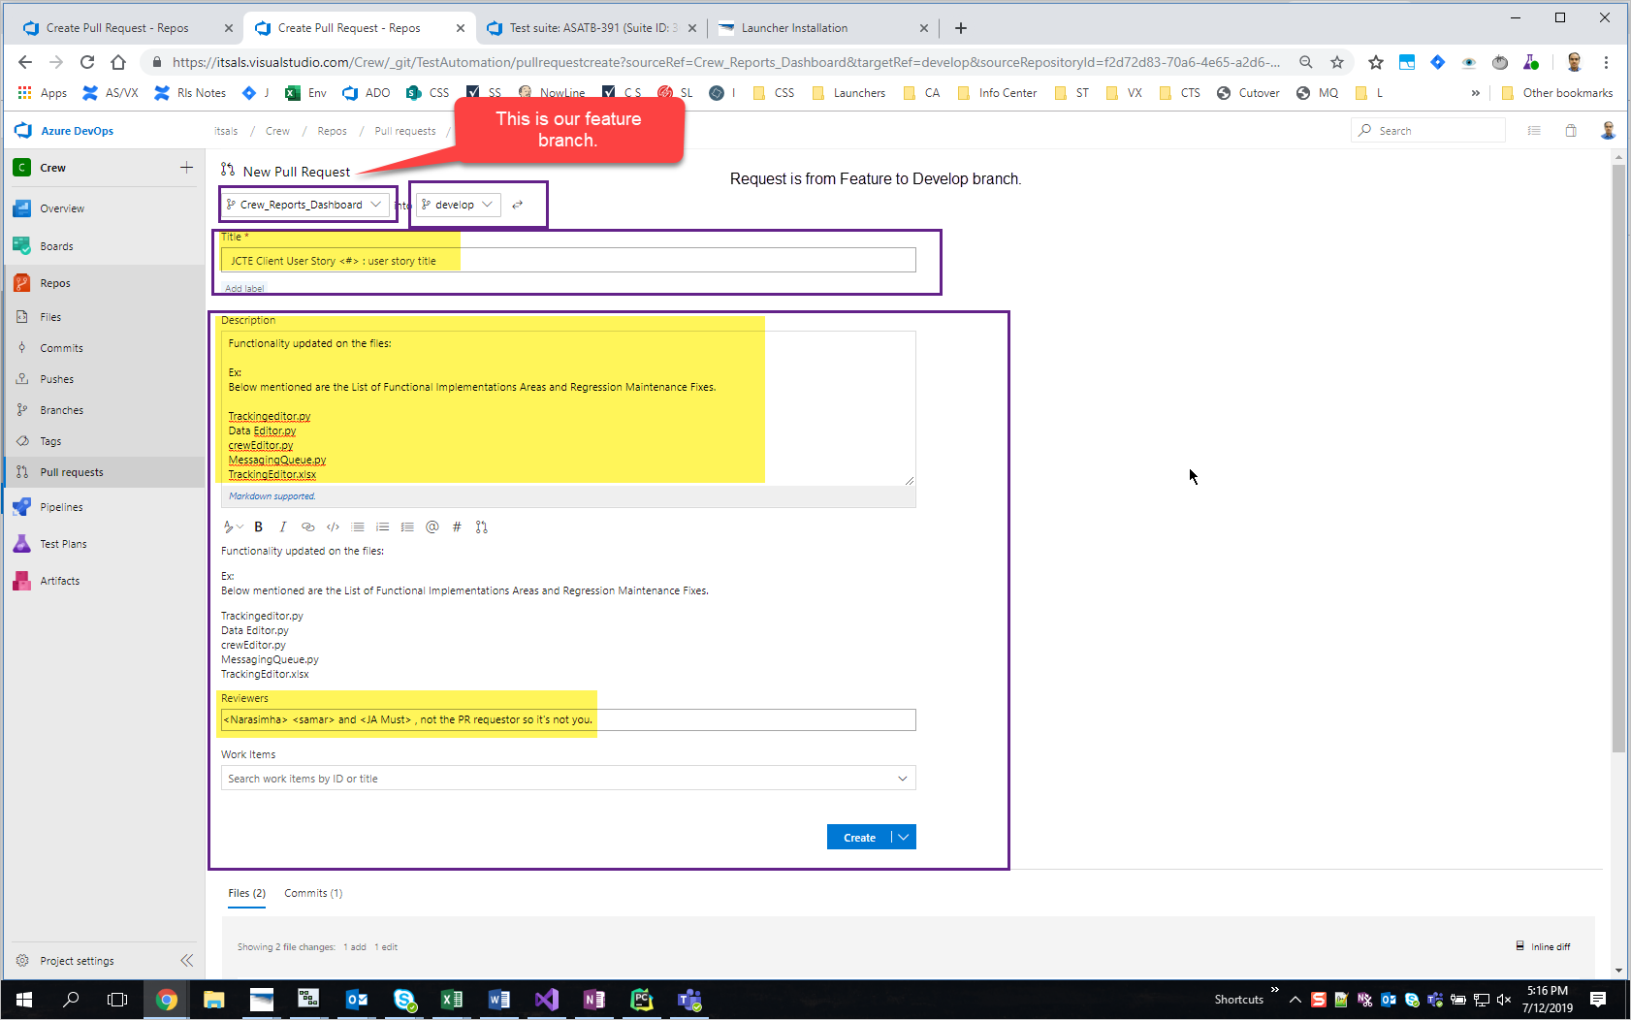

Need to enter all the data as mentioned above.

Please ensure to add Sai, Kaustav and JA (JA is must as he is the approver) as the reviewers.